Jane Ross Memorial Symposium
Wednesday, June 3, 2026 - Rolling Hills Zoo – 625 N. Hedville Rd, Salina KS

Name: ___________________________________________________________________________

Address: __________________________________________________________________________

Phone Number: ____________________________________________________________________

Email Address: ______________________________________________________________________

License Number (Please include which state): _____________________________________________

REGISTRATION/REQUEST FOR REFUND DEADLINE: May 28, 2026
$15 administrative fee for all refunds
Type of Registration:
ENA Member - $25 (Member number REQUIRED)
ENA Number: _________________________________________________

EMS - $50 (EMS License Number REQUIRED)
EMS License Number: __________________________________________

Non-ENA Member - $75

Checks to be made out to Kansas ENA
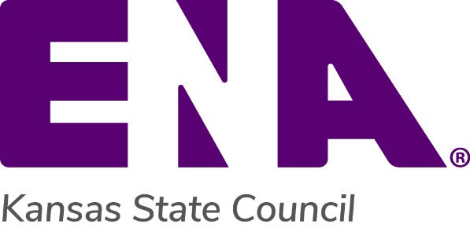
Please mail registration form and check to:
Carol Kappelman
7900 Cernech Road
Kansas City, KS 66109

